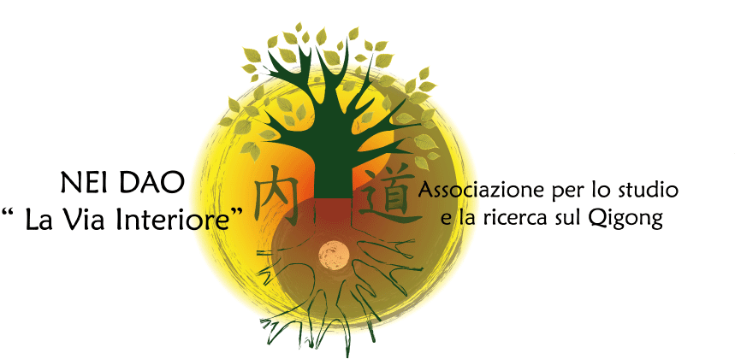

3rd INTERNATIONAL SYMPOSIUM OF QIGONG IN ITALY
“I am a Qi being!”
Inner consciousness for a better world

Rome, 18 - 20 October 2014

REGISTRATION FORM

Surname_____________________________________Name____________________________

Profession__________________Association/Organization/School____________________

Address________________________________________________________________________

(City) _______________ (State) _______ (Postcode) _______ (Country) _______________

Telephone: _________________ Email address: ____________________________________

I heard about the Conference through __________________________________________

Registration fee (individual):

by the 30/06/2014 € 200 + €15 transaction fee
by the 18/10/2014 € 250 + €15 transaction fee

For Group or Sponsorship fees contact Nei Dao Association directly.

Payment method:

Bank transfer of the amount Euro__________ made to the Associazione Nei Dao: Unicredit Banca di Roma, agency 07141, Viale Karl Marx, Roma –
IBAN code: IT15T0200805236000401371946
Swift (BIC) code: UNCRITM1J41
Payment reason: Registration to the Third International Symposium of Qigong in Italy

A copy of the payment receipt together with the registration form must be sent either by fax to (+39) 06 233291793 or by e-mail to info@neidao.org.

The undersigned declares that the details filled in above are correct and authorizes the “Associazione Nei Dao” to use them, within the limits of the Law 675/1996, only for the administration and relevant communications by the said Association.

Date……………………………. Signature ……..……………………………………

SEND TO: Associazione Nei Dao,
email: info@neidao.org.
fax: (+39) 06 233291793

________________________________________________________________________________
Associazione Nei Dao. sede: Viale Carlo Marx 198 - 00137 ROMA- C. F. 97598970586-Cell. 347.0583163 , www.neidao.org

