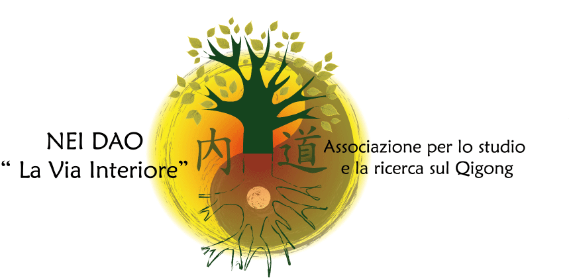

4th INTERNATIONAL SYMPOSIUM OF QIGONG IN ITALY
“Qi at work!”
Nourishment and awareness

Rome, 28 - 30 October 2017

REGISTRATION FORM

Surname_____________________________________Name____________________________

Profession__________________Association/Organization/School____________________

Address________________________________________________________________________

(City) _______________ (State) _______ (Postcode) _______ (Country) _______________

Telephone: _________________ Email address: ____________________________________

I heard about the Conference through __________________________________________

Registration fee (individual):

€ 250 + €15 transaction fee

For Group or Sponsorship fees contact Nei Dao Association directly.

Payment method:

Bank transfer of the amount Euro__________ made to the Associazione Nei Dao: Unicredit Banca di Roma, agency 07141, Viale Karl Marx, Roma –
IBAN code: IT15T0200805236000401371946
Swift (BIC) code: UNCRITM1J41
Payment reason: Registration to the Fourth International Symposium of Qigong in Italy

A copy of the payment receipt together with the registration form must be sent by e-mail to marisavocca@yahoo.it.

The undersigned declares that the details filled in above are correct and authorizes the “Associazione Nei Dao” to use them, within the limits of the Law 675/1996, only for the administration and relevant communications by the said Association.

Date……………………………. Signature ……..……………………………………

SEND TO: Associazione Nei Dao,
email: marisavocca@yahoo.it.

________________________________________________________________________________
Associazione Nei Dao. sede: Viale Carlo Marx 198 - 00137 ROMA- C. F. 97598970586-Cell. 347.0583163 , www.neidao.org

